Poster content for the Data Science for the Public Good summer program at UVA
Contact: Vicki Lancaster val7zv@virginia.edu

Identifying Skill Gaps in the Skilled Technical Worker Labor Market:
A Case Study in Two Virginia Metropolitan Statistical
using Burning Glass Technologies Job-ad and Resume Data

Introduction

A job in the Skilled Technical Workforce (STW) is a way for job seekers to enter the middle class without acquiring a bachelor’s degree. This research identifies the skills listed in the job-ads for two STW occupations, Critical Nurses (O*NET code 29-1141.03) and Maintenance and Repair Workers, General (O*NET code 49-9071.00); and compares them with the skills listed in resumes. The goal is to identify the skills most in demand by employers and least reported in resumes to guide job seekers in their attainment of credentials.

Skilled technical workers have occupations that require a high degree of technical knowledge, but do not necessarily require a bachelor’s degree. The Occupation Information Network (O*NET) database, which describes the knowledge, skills, and education of American workers in 1,000+ occupations, was used to identity these occupations in the Burning Glass Technology job-ad data. Following the Rothwell’s (2015) definition of the STW, we selected occupations with high O*NET knowledge scores in one of seven technical domains, where the majority of surveyed workers do not have a bachelor’s degree, master’s degree, or Ph.D.

Data
Burning Glass Technologies (BGT) is a Boston-headquartered labor market analytics firm founded in 1999, that uses artificial intelligence to collect and host a massive repository of workforce and employment data. The company markets both the data as a product as well as their consulting expertise on labor market questions to customers across a variety of industries, education institutions, local and regional governments, recruiting and staffing agencies, and corporate firms. This research uses the BGT job-ad and resume data.
- Job-Ad: BGT job-ads are collected using a web crawling technique that uses computer programs called “spiders” to browse approximately 50,000 online “job boards, corporate websites, and other places where job ads are posted.” The ads are broken down into five data sets include Job Information, Skills, Education Major, CIP Code, and Certifications.
- Resume: The resume dataset is a BGT proprietary dataset, sourced from Burning Glass partners. The resumes are broken down into five data sets Candidate Information, Education, Certifications, Skills, Jobs, and Employer.

Data Profiling and Preparation

Job Information Data Set

BGT Job-ads
2016-2017
USA Job Information Data Sets

BGT Job-ads
2016-2017
USA Skill Data Sets

from 24 skills data sets select ads in
VA
from 24 job information data sets select ads in VA

Merge
Reduced Job Information and Skills Data Sets by Job-ad ID

2016-2017
VA Skills Data Set
(N=####)

2016-2017
VA Reduced
Job Information
Data Set
(N=####)

2016-2017
VA Job Information Data Set
(N=####)
Keep Jobs Ads:
>in MSAs 40060 & 13980
>with an education requirement of $≤$ 14 years or no education
>with O*NET codes 29-1141.03 and 49-9071.00

Add a variable for hard and soft skills. A "soft skill" is either personality-based, primarily used to interact with coworkers, or a general way of approaching a problem. Oral communication, teamwork, and creativity are soft skills. A "hard skill" requires domain-specific knowledge or can be easily measured and evaluated. Typing, Microsoft Excel, and financial accounting are hard skills. Five researchers manually identified each skill based on the above definition. Their results were then aggregated and used to create a skill type variable.

2016-2017
VA Job Information + Skills Merged Data Set
(N = ####)


Candidate Information (Resume) Data Set

BGT Resumes
2016-2018
USA Skill Data Sets

BGT Resumes
2016-2018
USA Candidate Data Sets

from over 2200 skill zip files select candidates in VA
from over 2200 candidate zip files select candidates in VA

Merge
Reduced Candidate
Information and Skills Data Sets by Resume ID

2016-2018
VA Skills Data Set
(N=####)

2016-2017
VA Reduced
Candidate Information
Data Set
(N=####)

2016-2018
VA Candidate Information Data Set
(N=####)

Keep Candidate Resumes:
>In MSAs 40060 & 13980
>Keep only those resumes that do not have a data in 2018

Add a variable for Bachelors and no Bachelors degree. The resume education data table contains a field, “degree-level,” that provides the number of years of study for each degree (e.g. high school is equivalent to 12). This field was frequently left blank; however, using only the degree-level field, we were able to find the maximum years of study for 68% of the job candidates. To classify a larger portion of the resumes, we performed several exploratory analyses to increase the classification rate. We checked the related fields, “institution name”, “major”, and “degree type”, for information indicative of the degree-level. We used the following criteria to guide our classification.
a. Virginia’s Community Colleges only grant associates degrees (https://courses.vccs.edu/programs).
b. Trade schools (including culinary schools, cosmetology colleges, and other vocational trainings) do not grant bachelor’s degrees.
c. High schools and GED were determined to be non-bachelors.
d. Wording that indicated partial college, such as “some college” or “course-work in” were determined to be non-bachelors.
e. Other associate degrees were found by searching for variations of the “associates” and acronyms like “AA” and “AAS” in the degree type field. By using these search criteria and aggregating our results, we increased our categorization rate by 11%, identifying the maximum education level for 79% of resumes.

2016-2017
VA Candidates + Skills + Education Merged Data Set
(N = ####)

x

from over 2200 education
zip files select candidates in VA and merge with candidate and skills

BGT Resumes
2016-2018
USA Education Data Sets

Exploratory Data Analysis

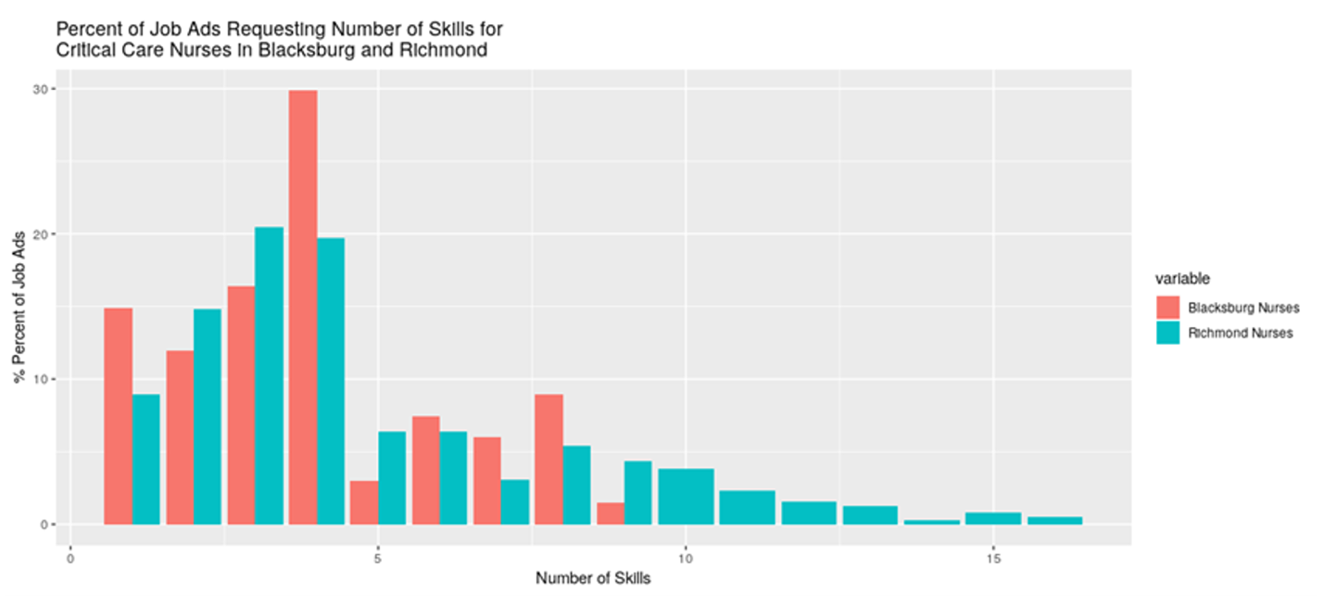
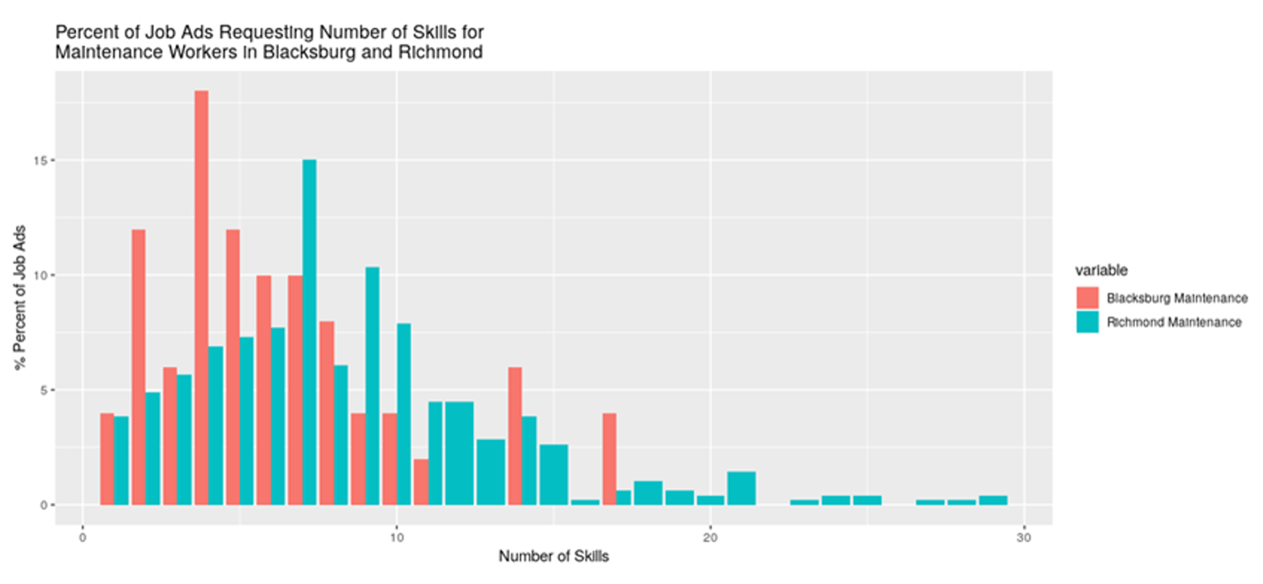

The figure plots the percentage of times a particular skill appears in a job ad on the vertical axis. On the horizontal axis the relevance of the skill is plotted. Relevance calculates the number of skills per job-ad; weights each skill within the job-ad by one over the number of skills; and sums the weight for each skill. Skills that appear more frequently in a job-ad and are listed with fewer other skills have a higher relevance score.

These plots are used to identify the core skills which are used to select resumes to use in calculating the mismatch between job-ads and job seekers in an MSA.

Skill Mismatch

To identify candidates for a particular job, Critical Care Nurses or Maintenance and Repair Worker, General, we selected resumes in an MSA where a candidate possessed at least one core skill for that particular job. A core skill is defined as a hard skill found in at least 30% of job ads (see previous figures) for a particular job. We then compared the skills of each candidate to every job posting in that MSA. The mismatch distribution is constructed by counting the number of skill matches, job ad against candidate and dividing by the number of skills in the job-ad.

Critical Care Nurses
For Critical Care Nurses, there were 266 candidates to 203 resumes in Blacksburg and 267 candidates to 1462 resumes in Richmond. Overall, this suggests that there are somewhat fewer Critical Care Nurse jobs available than potential candidates to fill them in Blacksburg, while the reverse is true in Richmond.

There were 4 core skills for Critical Care Nurses in Richmond: Critical Care Nursing, Advanced Cardiac Life Support, Neonatal Intensive Care Unit, and Patient Care; core skills in Blacksburg were identical but excluded Neonatal Intensive Care Unit. In terms of skill overlap, the average match of skills a particular job advertisement can hope to achieve was 0.2 in Blacksburg and 0.026 in Richmond, given the disparity in supply on Critical Care Nurses. The match of each individual to a particular ad ranged from a perfect match (1) to no overlap whatsoever (0). The distribution of skill match of Critical Care Nurse candidates of any education level to individual job ads is shown in Figure 1 for Blacksburg and Figure 2 for Richmond. The distributions have a floor effect, with many people showing no overlap, but several jobs had at least one candidate who had every requested skill.

Figure 1. Skill Mismatch Distribution for Critical Care Nurses in the Blacksburg MSA
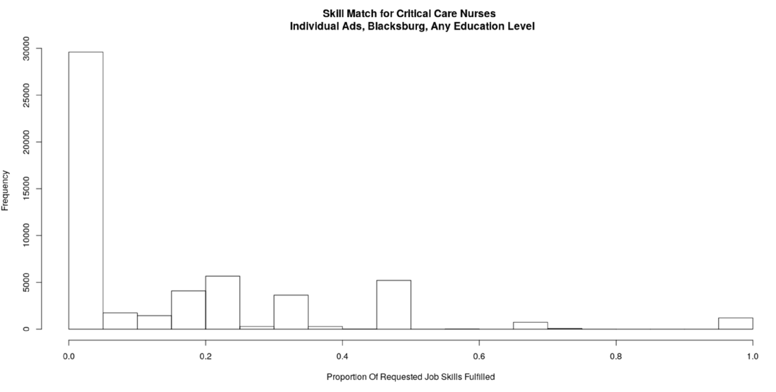

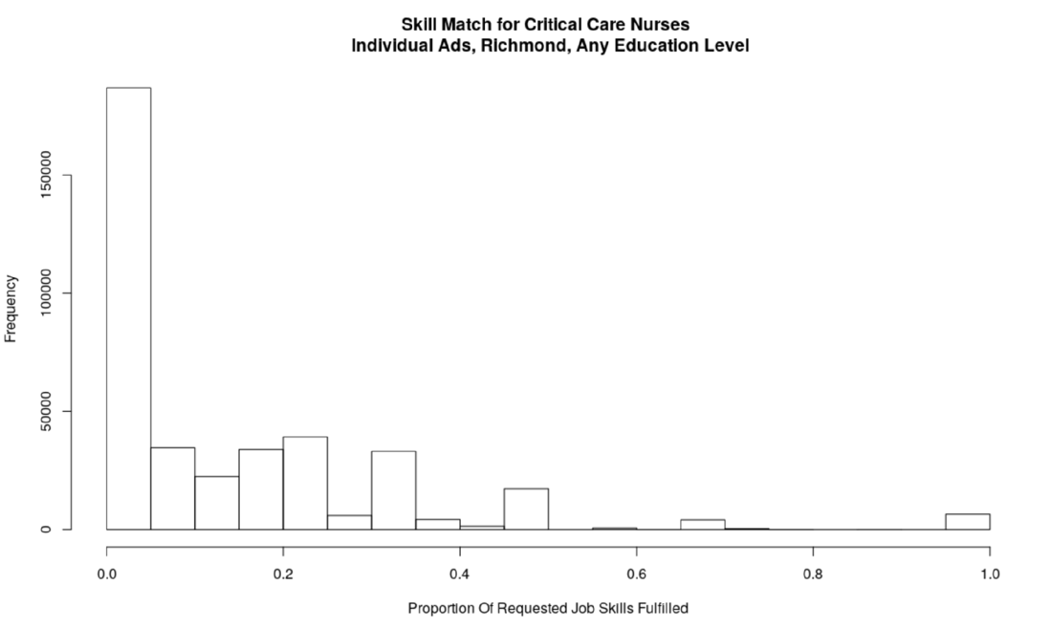
Figure 2. Skill Mismatch Distribution for Critical Care Nurses in the Blacksburg MSA

Which skills in particular are especially in demand among employers? Figure 3 illustrates the demand and availability of the top 20 Critical Nursing skills in Richmond (See Figure 4 for Blacksburg). The horizontal axis shows the proportion of ads requesting a particular skill—skills further to the right are more commonly requested. For example, many ads requested Critical Care Nursing, but less than 10% requested Teaching. The vertical axis shows the availability of a skill compared to demand, using the difference between the proportion of jobs requesting a skill and the proportion of candidates with a particular skill; skills above 0 on the vertical axis indicate candidates tend to list this skill more frequently than it is listed in jobs ads (suggesting a larger supply than demand for a skill), and skills below 0 indicate skills that job ads request more frequently than candidates do (suggesting a greater demand for this skill). Less candidates listed Trauma (Richmond) or Surgical Services (Blacksburg) as a skill than job ads, suggesting that amongst job ads, there will be greater competition for candidates with this skill; more candidates listed the Customer Service skill than was listed in job ads, suggesting this skill would not significantly favor one candidate over another.

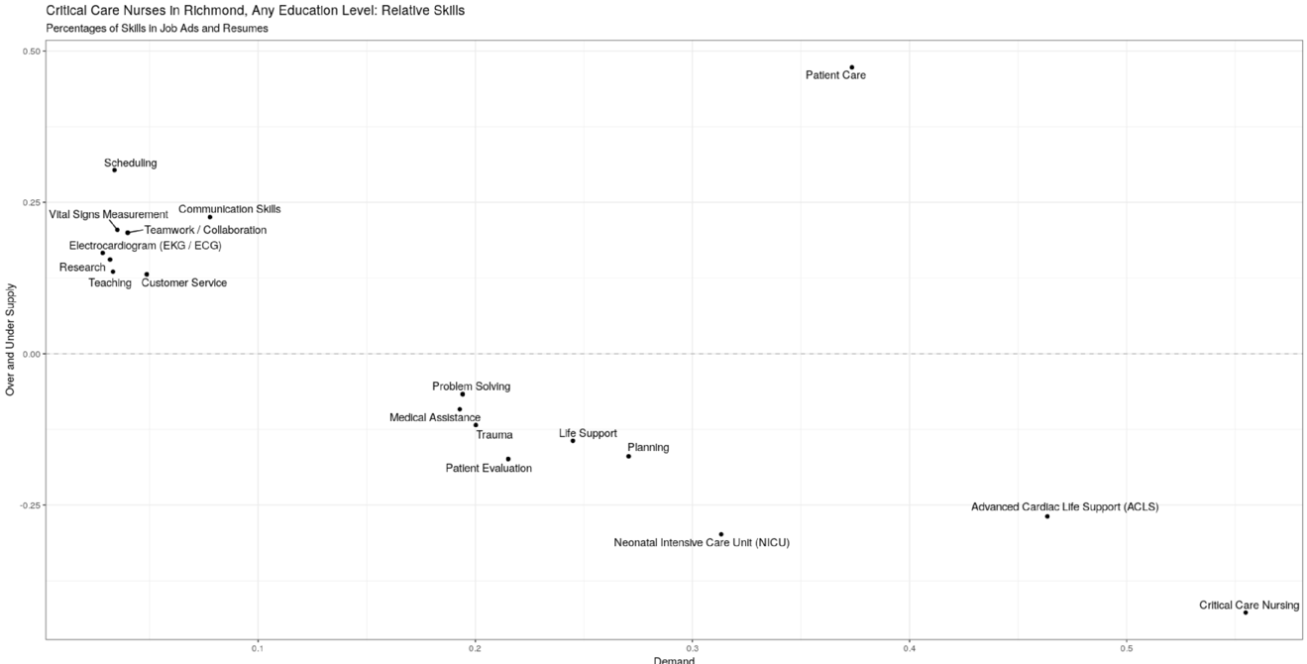
Figure 3. Under- and Over- Supplied Skills for Critical Care Nurses in the Richmond MSA

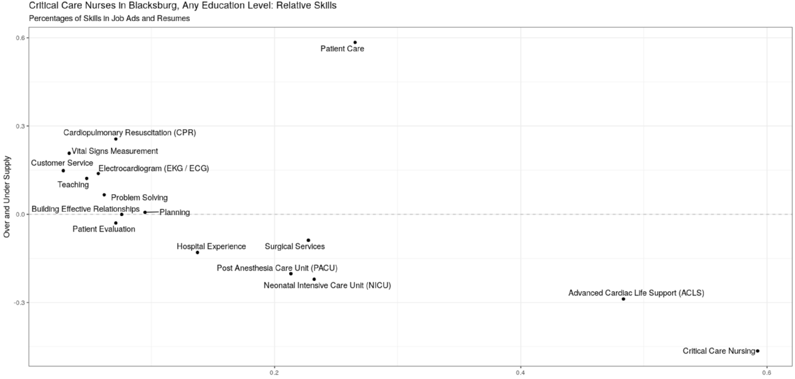
Figure 4. Under- and Over- Supplied Skills for Critical Care Nurses in the Richmond MSA

In Richmond, Critical Care Nursing was the skill most often requested for Critical Care Nurses (naturally), but was generally emphasized in more ads than resumes, suggesting there would be more demand and therefore significant competition for candidates with this skill (a similar patterns occurs for two other core skills, Neonatal Intensive Care and Advanced Cardiac Life Support). In contrast, Patient Care is a core skill both often requested but also highly common in resumes, suggesting it is a skill that employers both value but can expect to find in most candidates. Scheduling (soft skill) is a skill that was listed by many candidates, but is rarely requested in job ads, suggesting candidates listing this skill may not significantly increase the likelihood of being hired. A similar pattern occurs for Blacksburg.

This will be repeated for Maintenance Repair Workers, General

The O*NET-SOC taxonomy. O*NET Resource Center. Available at https://www.onetcenter.org/taxonomy.html. (accessed May 15, 2019)
Rothwell, J. (2015). Defining skilled technical work. Retrieved from the National Academies of Science website: https://sites.nationalacademies.org/cs/groups/pgasite/documents/webpage/pga_167744.pdf (last accessed July 28, 2019)
Burning Glass Technologies https://www.burning-glass.com/about/faq/ (last accessed May 15, 2019)

